**NNFL EXPT-3**

**Fuzzy Controller for Grading using Sugeno inferencing**

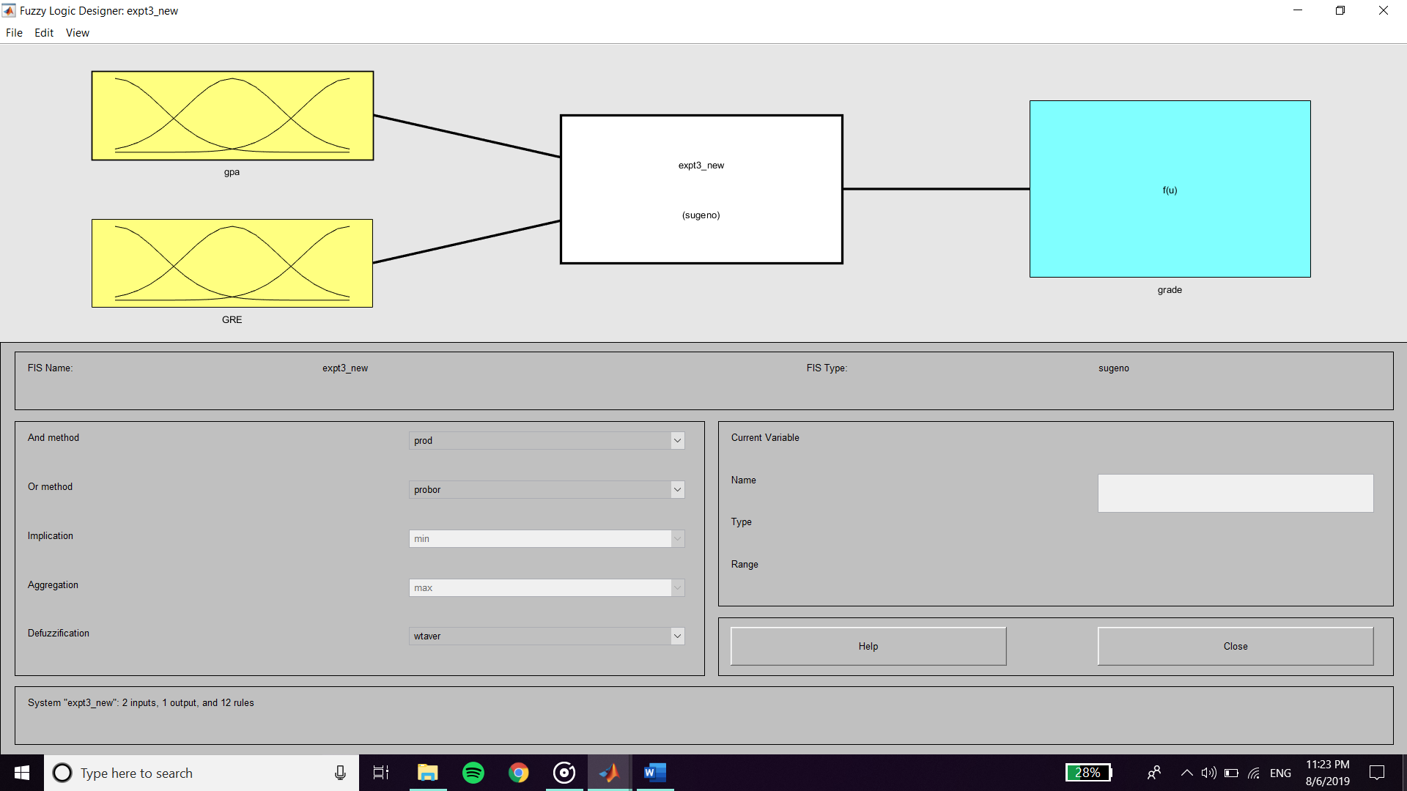

**Inputs :**

**Membership Function of GPA**

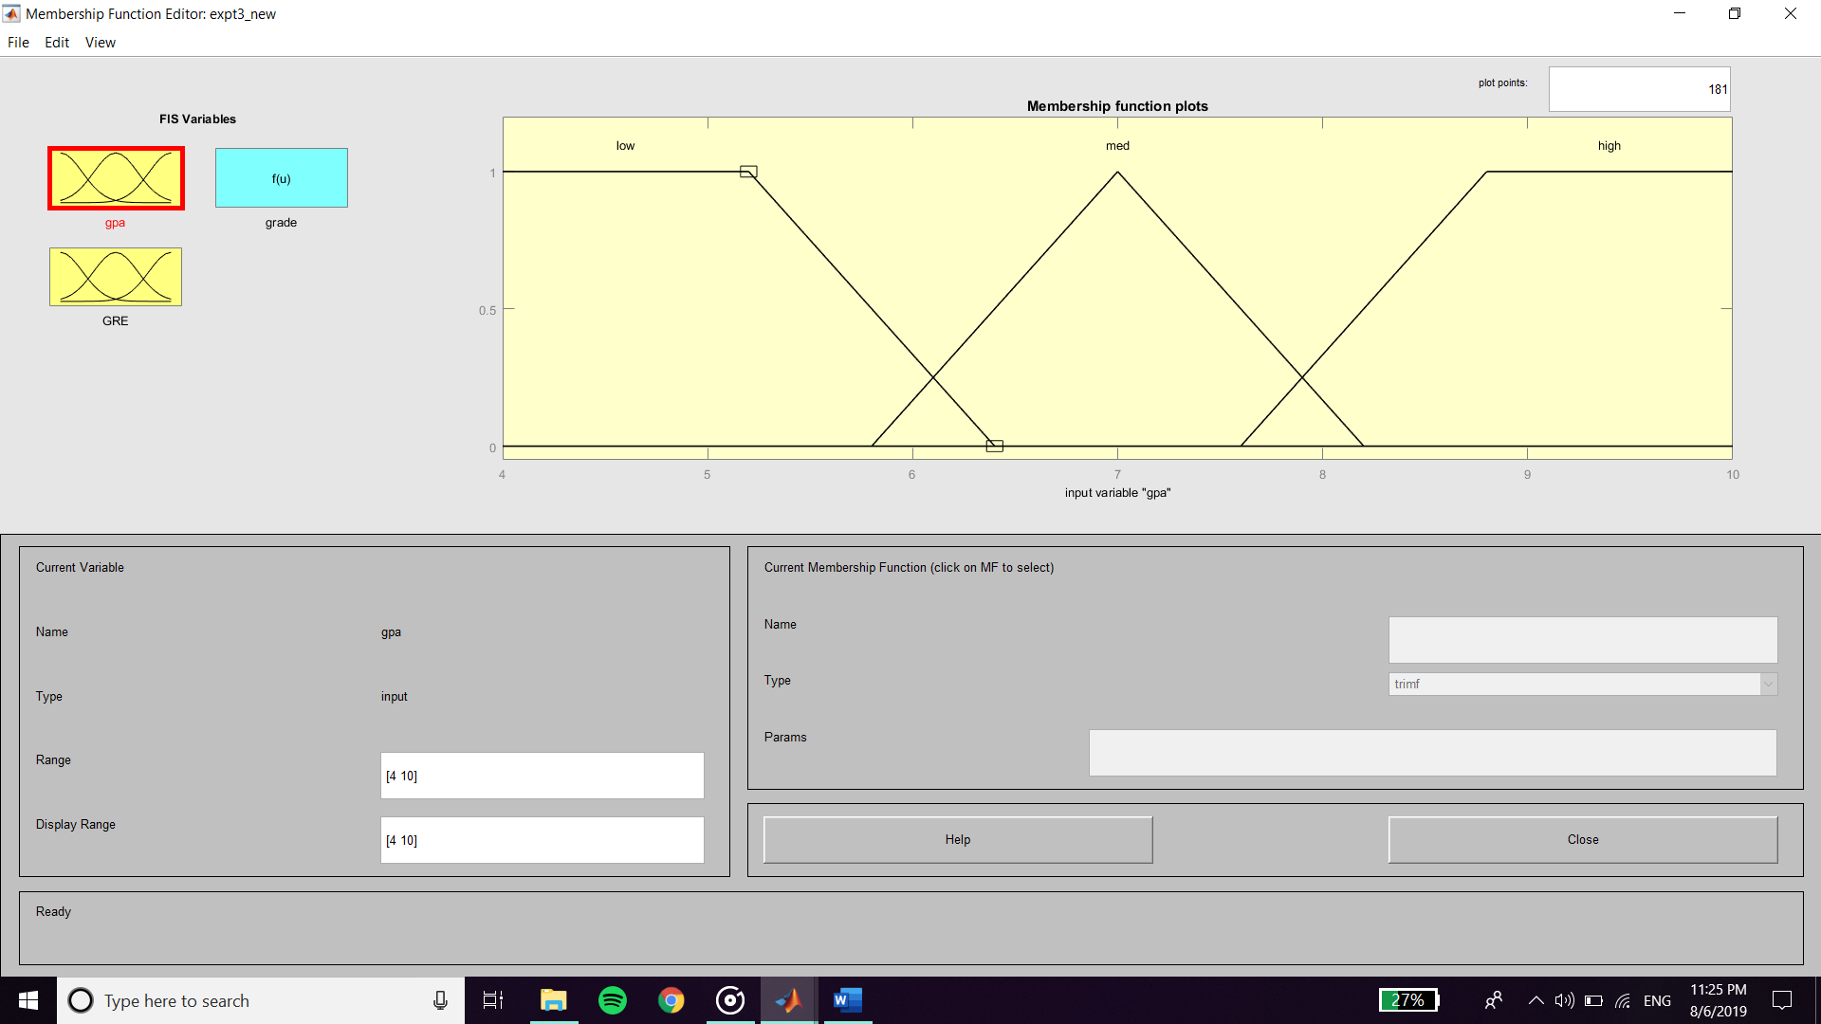

**Membership Function of GRE**

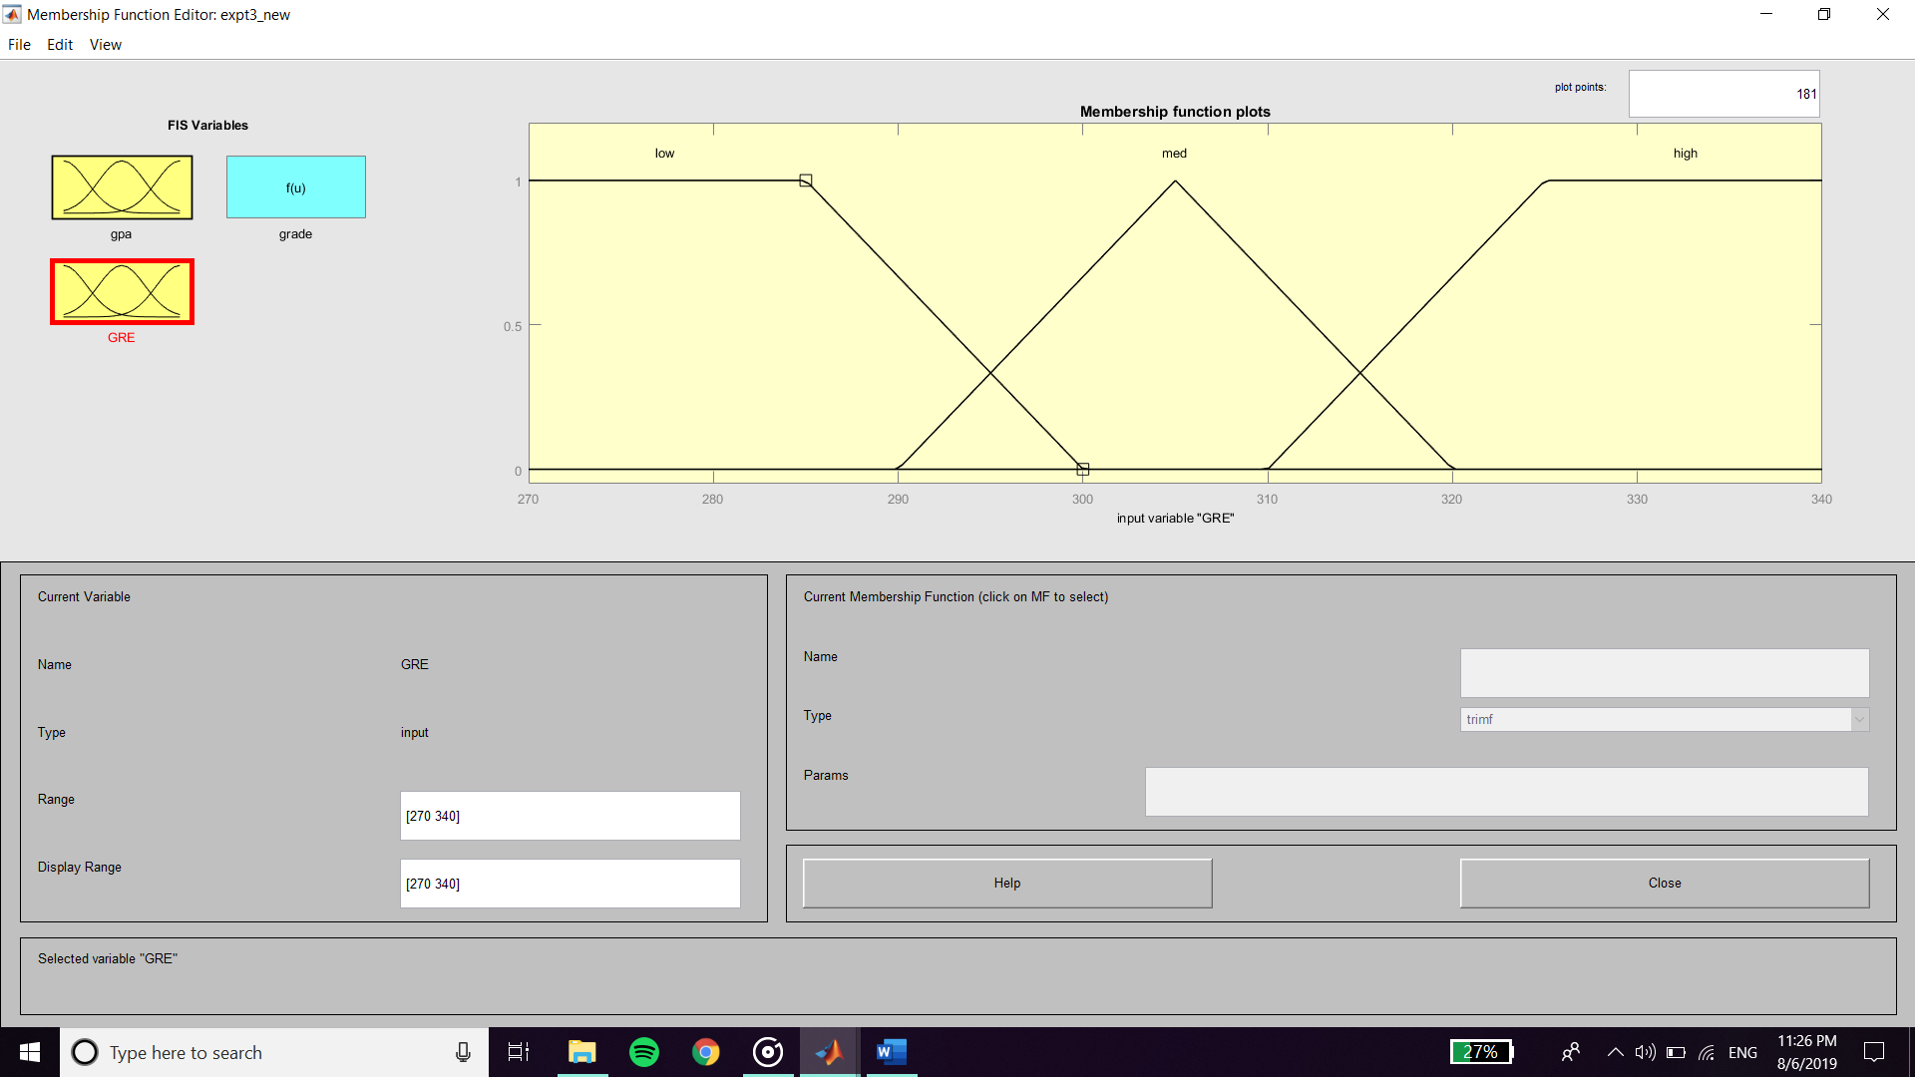

**Output :**

**Membership Function of Grade**

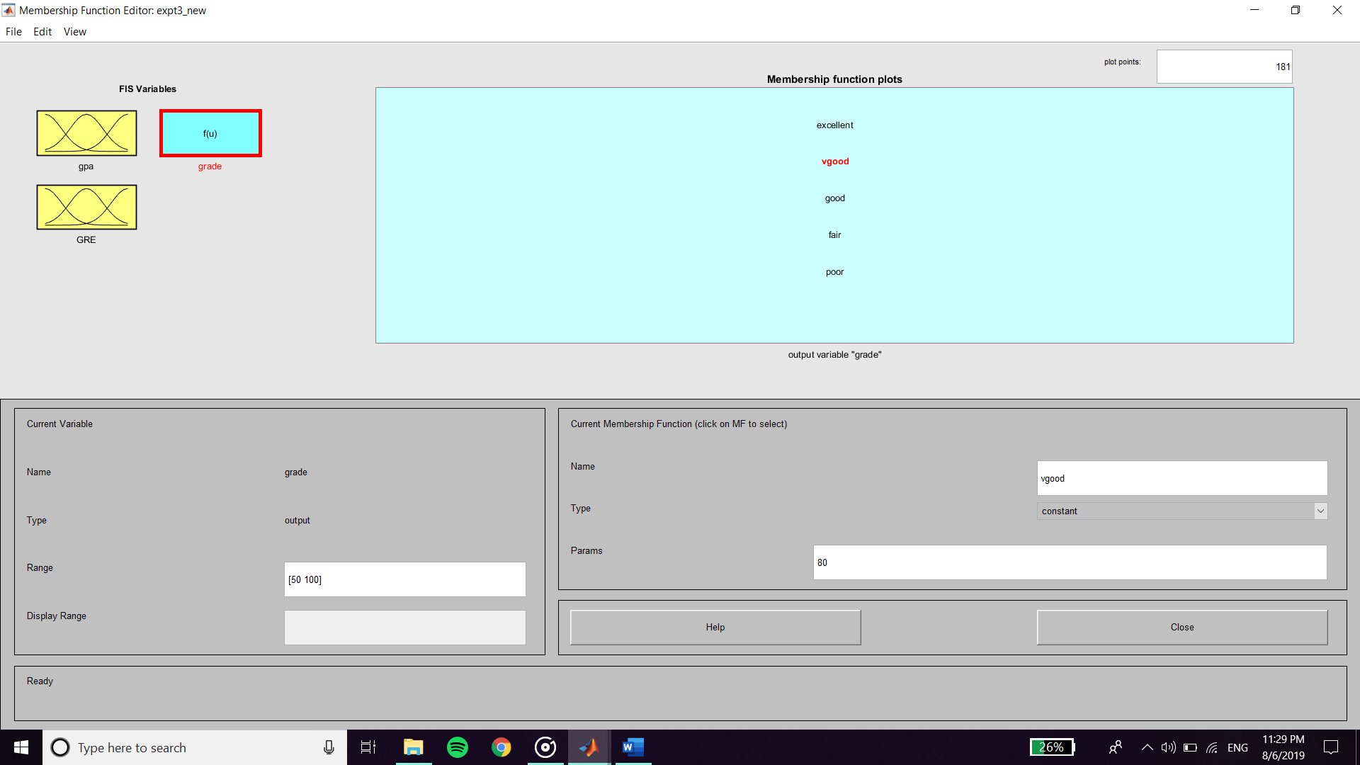

**Rule Base**

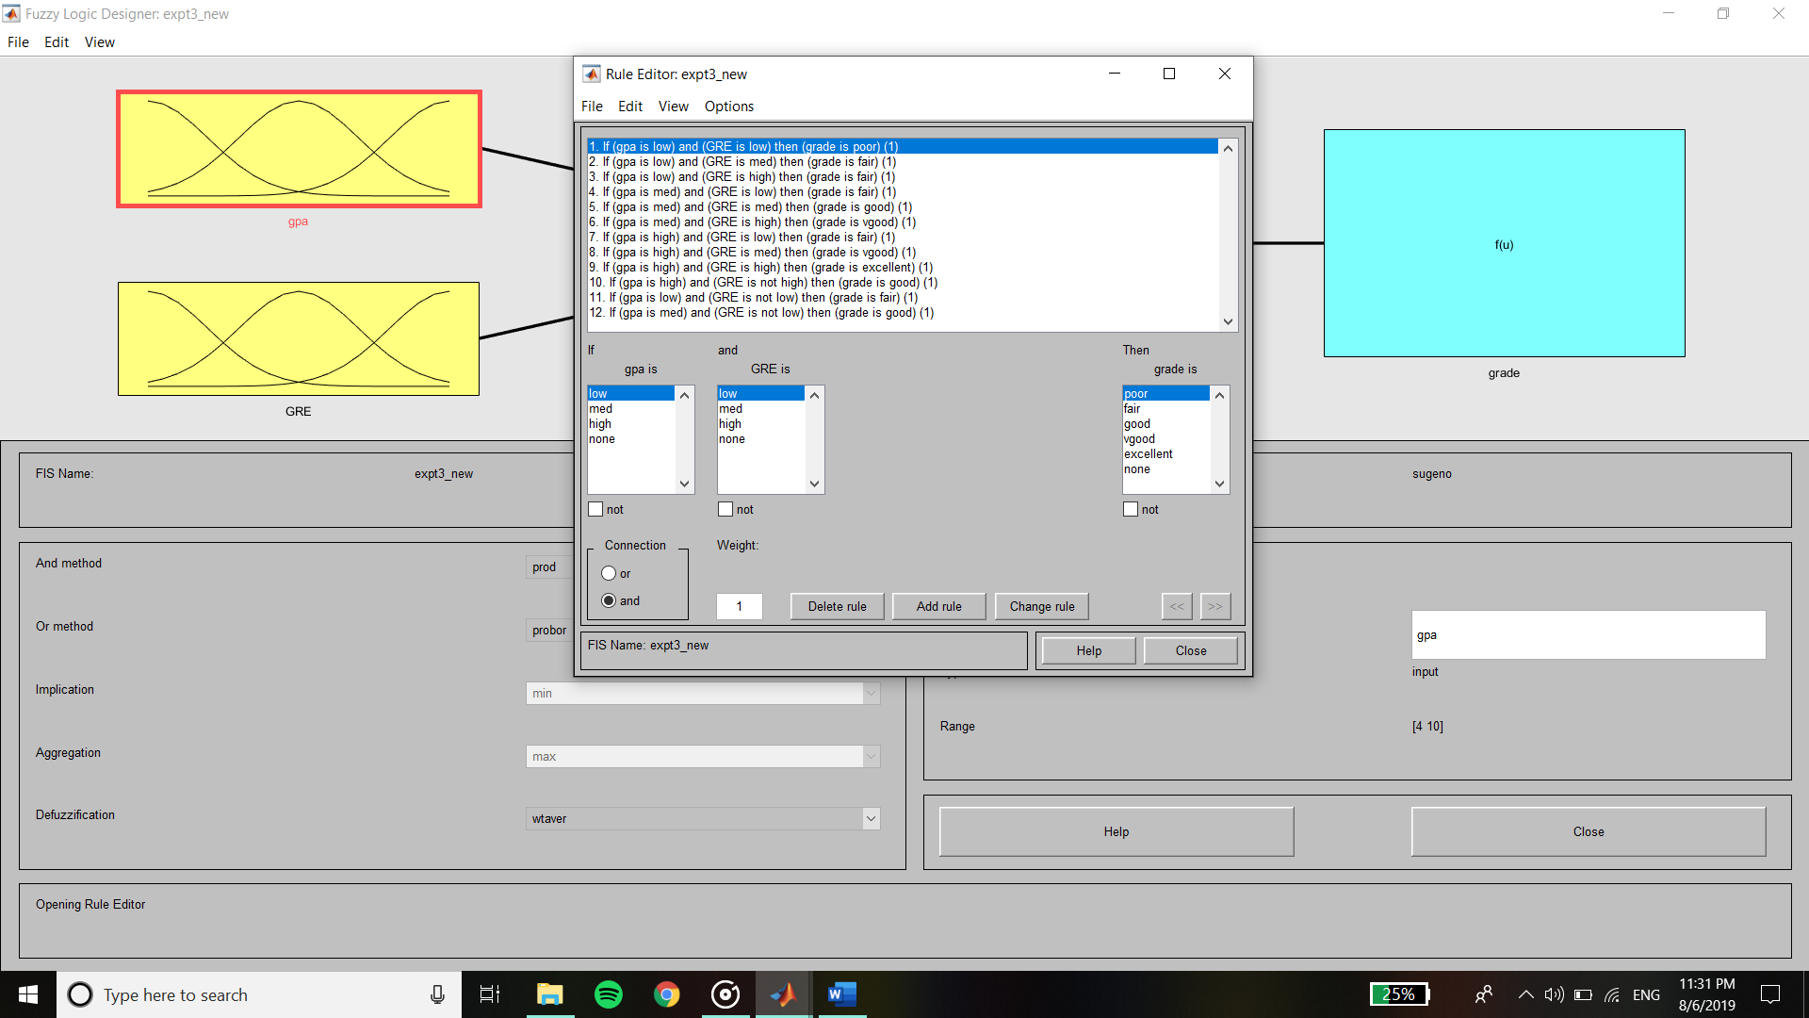

**Output :**

**For GPA = 8 and GRE = 315**

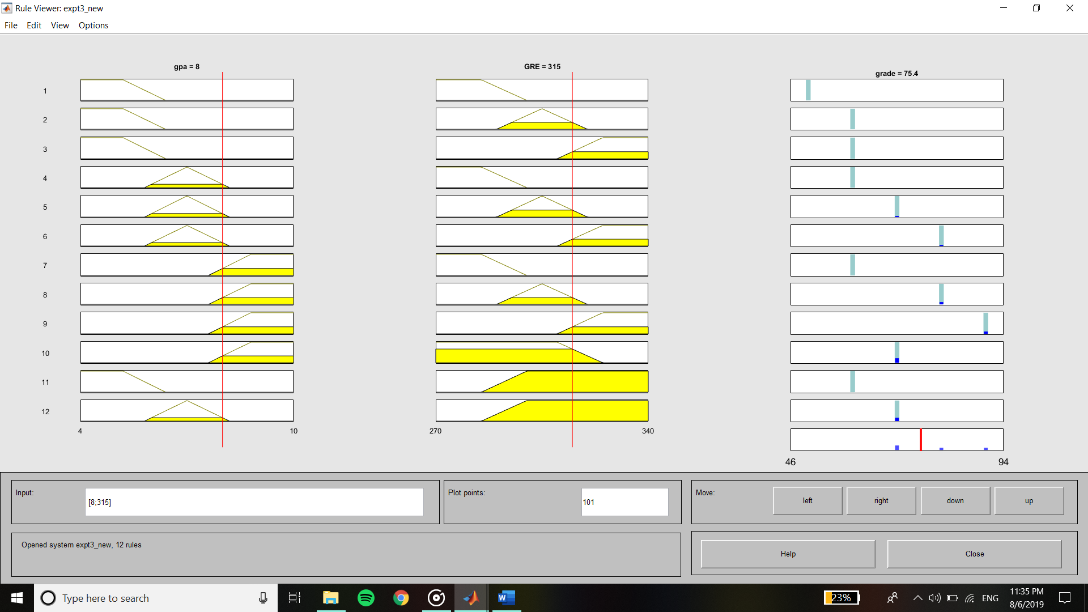

**Surface Viewer**

